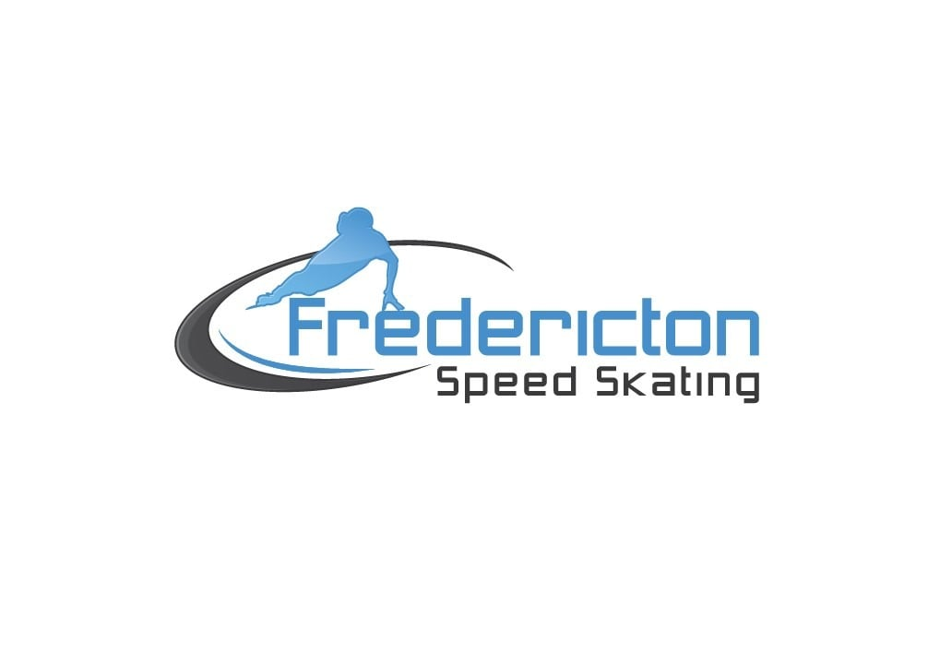

**FREDERICTON AMATEUR SPEED SKATING CLUB (FASSCI)**

**2023-2024 ~ Learn to Skate Registration Information**

**Registration:** [**https://icereg.ca**](https://icereg.ca/#!/)

**Location: Grant Harvey Main Entrance (Foyer) - 600 Knowledge Park Drive, Fredericton**

**At FASSCI, we strive to provide a sport experience based on the values of fairness, excellence, inclusion & fun. We follow and promote the True Sport Principles and take great pride in teaching your children how to skate from the child who has never been on the ice to the athlete striving to be on a Provincial, National or Olympic team and anywhere in between.**

**Learn to Skate program** ($304 for 15 weeks)

This program has been crafted to engage children approximately 4 - 8 years of age through a fun and friendly environment. Skaters will gain confidence and develop skills in balance, control, and agility. Canada Games medallists and National Team members have taken their first steps on ice with this program. A and B skaters assist in coaching as part of our giving back initiative.

* 15 sessions, program runs from October 2023 – March, 2024.
* Sessions are Fridays 6:00-7:00 pm.
* Please note that the program is scheduled as 15 sessions. Friday cancellations do occur. Cancellations are usually due to city tournaments that affect our schedule.
* Reduced hours will be in place during both Christmas and March breaks.

**EQUIPMENT**

**Learn to Skate** skaters are recommended to wear hockey skates or figure skates with picks removed. All skaters must wear long sleeved clothing, a helmet including a face mask, protective gloves, and volleyball style knee pads (avoid hockey pads and roller skating pads - the hard plastic is slippery and makes getting up much more difficult)

**WITHDRAWAL**

Please note that a $50 non-refundable portion is included in the fees for all programs. Skaters in these groups **who withdraw after November 17, 2023 will not be entitled to a reimbursement.**

**COMMUNICATION**

All communication (announcements, cancellations, upcoming events, etc.) will be done through e-mail (fassci@gmail.com) and our web site (**[www.frederictonspeedskating.com](http://www.frederictonspeedskating.com)**). To receive email communications, please ensure that your email address is included on the registration form. All e-mails sent to you will be from FASSCI@gmail.com.

**REGISTRATION**

All skaters must be registered prior to first session on the ice.